Dream Big. Aim High.

Sarina State School
Parent and Community Engagement Framework 2023- 2027
Our Vision: Quality Education Equal Opportunity
Our school is firstly a place of learning in an inclusive environment. The Parent and Community Framework identifies how Sarina State School and our parents and the broader community work together to focus on providing quality education and equal opportunity. As a rural school we rely heavily on local partnerships to improve learning outcomes and student wellbeing and to provide opportunities for our students’ in understanding their role in their community.
Our Purpose – To prepare Sarina SS students with the knowledge, skills and confidence to participate effectively in the school community and beyond. This framework outlines how Sarina State School strengthens student outcomes through the five domains of the Department of Education’s Advancing Partnerships – Parent and Community Engagement Framework.

Communication at Sarina State School (D3)
Communication at Sarina State School is focused on effective communication between our cluster schools, parents, students and the community. Communication is driven by student learning and wellbeing, to significantly impact student outcomes. Communication platforms include: QSchools, SMS, FB, school website, Enrolment and Parent Teacher Interviews, regular contact home by staff, Celebration of learning days, Awards Ceremony, Kindy and year 6 Transition information days.

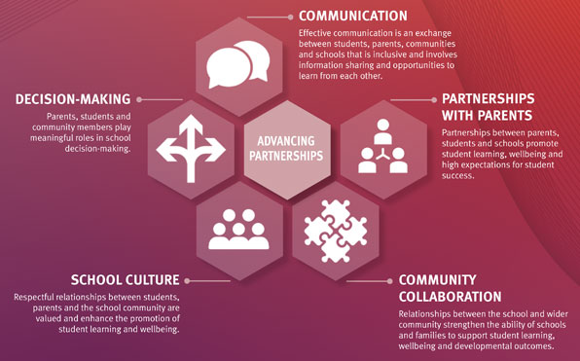
School Culture (D3 & 9)
Respectful relationships between the school, students, parents and the school community need to be actively cultivated and valued. At Sarina State School we promote the value of education, positive interactions and celebration of learning through a variety of opportunities. Recognition of positive behaviour, Kiki Coins, calendar of events on website, term assemblies, transition days, Term celebration of learning day, Aboriginal and Torres Strait Islander and South Sea Islander dance group, NAIDOC celebration, ANZAC Day assembly.
Community Collaboration (D9)
Schools do not exist in isolation, community members and organisations offer unique knowledge, expertise and perspectives. At Sarina State School we work with community to support our students’ wellbeing and ability to come to school ready and able to learn. Our Community Partners are listed in the front foyer, common room and offices.
Partnerships with Parents (D3 & 9)
Recognising parents and families as integral members of the school community and partners in student learning is essential. At Sarina State school we offer and encourage opportunities to build partnerships through our P & C Committee, before school reading program, provision of parent information sessions- (how to teach reading), cyber safety workshops and our weekly school parades.
Decision Making (D9)
Parent and community involvement in school decision-making encourages greater ownership and ensures local needs are reflected. Consultation process with all stakeholders is vital in supporting informed decision-making. At Sarina State School, Monthly P & C meetings, SOS, acknowledging and responding to parent feedback, Survey Monkey to gather feedback and input are strategies in place to ensure parents and community are consulted and have input into decision making.

