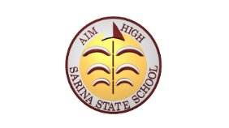
Sarina State School
Dream Big. Aim High.

Sarina State School
Student Learning and Wellbeing Framework 2023- 2027
Our Vision: Quality Education Equal Opportunity
Our school is firstly a place of learning in an inclusive environment. The Student Learning and Wellbeing Framework focuses on building a foundation of engagement in learning, through growing healthy, confident and resilient young people. By focusing on wellbeing of all students we are creating a sense of belonging and a positive learning environment.
Our Purpose – To prepare Sarina SS students with the knowledge, skills and confidence to participate effectively in the school community and beyond. This framework outlines how Sarina State School strengthens student outcomes through the Student Learning and Wellbeing Framework.

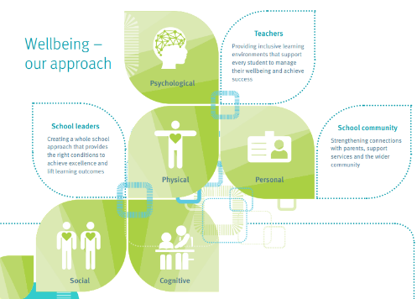

Building the capability of staff, students and the school community.
Sarina State School provides health and wellbeing learning opportunities for students through curriculum focused on mental health, relationships, food and nutrition, physical activity and safety.
We do this by
- Yearly cyber safety training provided to students via Police cyber training experts
- Working with Outside Agencies: Sarina Youth Centre, Mudth- Niyleta, Act for Kids, Uniting Care; Minds Alive, ATSICH, Relationships Australia, MADEC, Child Youth and Mental Health (CYMHS),
- Identifying opportunities to build the capabilities of teachers and school leaders to support a wholes school approach to student wellbeing and its connection to learning. Networking with other schools and the CLAW.
- Providing access to Suicide and Self Harm prevention training for teachers and broader staff.
- Communicating information and advice on the benefits of supporting young people to be healthy, confident and resilient through the curriculum, Positive Education focus lessons and through our school FB and QSchools.
- Responding positively to the needs of different groups within the school community including our primary school Transition program.
- Strengthening connections with parents to support early intervention for student whose wellbeing is at risk through our HOSE and GO.
- BASA committee to support student wellbeing and health providing referrals where necessary.
- Collecting and analysing a range of data, including Learning Walks and Talks, review of the SOS and One School data to identify areas for capability building of staff.

Creating safe, supportive and inclusive environments
Sarina State School provides a safe environment where diversity is valued, positive social interactions are promoted, and risk of injury or harm is minimised.
We do this by
- Approaching wellbeing that supports the collective action of parents, support services and the wider community by meeting for regular consultation with the P&C, Positive Education Team, Behaviour, Academic, Social and Attendance (BASA) Team and through collaborative planning for teachers.
- Demonstrating and communicating positive respectful relationships between staff, students, parents and members of the community through the implementation of our Student Code of Conduct, Positive Education focus lessons and explicit teaching of our 4 school expectations.
- Ensuring the physical environment and school policies and practices are accessible and inclusive of students and families.
- Planning and providing opportunities to promote and celebrate the traditions, values and cultures for the school community. NAIDOC week, Easter, ANZAC Day, National Day of Action against Bullying, Remembrance Day, Celebration of learning days.
- Celebrating the academic, sporting and cultural achievements of our students at weekly parades, Annual Awards afternoon, and with the community through QSchools, Face Book, weekly school parades.

Developing strong systems for early intervention.
Sarina State School has planned and documented school processes to support staff to respond appropriately to students at risk.
We do this by
- Collecting NCCD data
- Case Management meetings- Marker students
- Data Analysis Planning (DAP) meetings, including PLRs, ICPs
- Collaborative Assessment of Student Work – (CASW) meetings
- Moderation process
- Third Teacher – Anchor charts, Bump it up Walls, Co-construction of learning walls
- Recognising the early signs that a student’s wellbeing is at risk and responding appropriately using the referral process for BASA.
- Sharing responsibility for supporting students at risk by: integrating DoE support services to assist in planning and implementing practices that improve outcomes for students including support from our Speech and Language Pathologist, Physiotherapist, Occupational Therapist and Advisory Visiting Teachers.
- Student protection and code of conduct training.
- HOSE and GO develop support plans for students including Health Management and Support Provisions.
- QEW Survey

