SARINA STATE SCHOOL
UNIFORM SHOP PRICE LIST
& INFORMATION

Located directly adjacent to Tuckshop & Undercover Area in Cottage.
Trading Hours: Monday’s 8.30am – 9am
We accept All Payment Methods

We also have out online shop:
https://sarinasspandcuniform.square.site/

Online orders will be packed and sent to the office for collection on the next uniform shop day.

Items | Details | Sizes | Price | Product Image
Polo  Shirts | Youth Size  Adult Size | 4-14  XS-XXL | $35 | 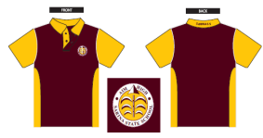
Shorts | Cotton back shorts with zipper pocket | 4-14  XS-S | $25 | 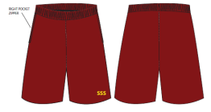
Skirt  Combo | Cotton back combo with zipper pocket | 4-14  XS-L | $30 | 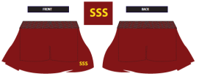
Hats | Reversible Bucket Maroon  With  Yellow, Green and Red | 54cm (S)  Or  58cm (L) | $20 | 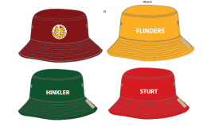
Socks | 3 Pack of Socks | K9-12, K13-3  2 - 8 | $15 | 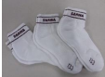
Bags | Library Bag (vinyl waterproof) |  | $18 | 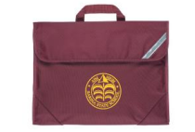
Bags | Homework Bag (vinyl waterproof) |  | $20 | 