Sarina State School Term 4 Week 3 Insights from the Principal
Our vision: Quality Education Equal Opportunity
Our motto: Dream Big. Aim High.
Yuwi Country
Welcome to Term 4
Term 4 here we go! This term will pass by in a flash. Week three already, with lots happening around the school. On Friday our annual Sarina on the Green is being held. This will commence at 6 pm. The P&C are providing hot dogs and drinks for purchase. Sarina on the Green will be showcasing our talented students and teachers. Bring a picnic rug and refreshments and sit back and take in our wonderful performers.
4-year Strategic Plan 2024-2027
The priorities for our school over the next 4 years will be:
Academic Excellence – [DoE] Educational Achievement
Positive Education – [DoE] Wellbeing and Engagement
Inclusive Education – [DoE] Culture and Inclusion
An inquiry planner outlining the 4-year strategic plan has been completed and the 4-year strategic plan placemat/document is in draft form. Once this document has been created, the 2024 Annual Improvement Plan will be created, aligned to the 4-year plan.
2023 School Priorities: 1. Deepen teacher’s knowledge and increase teacher confidence in delivering the Australian curriculum across all learning areas; and 2. An inclusive school achieving success for diverse learners. The 2023 AIP is now coming towards fruition with targets and goals being met. There are some areas that were not achieved; however, these areas will be incorporated into the 2024 AIP as ongoing goals. Targeted areas for 2024 will be; refining our whole school approach to case management and implement consistently and develop capability of staff with social and emotional learning.
Our Explicit Improvement Agenda (EIA) for the next 4 years, will focus on collaboratively developing a suite of agreed school-wide pedagogical approaches to support t the learning of all students, including First Nations, South Sea Islander and diverse learner.
Staffing
I would like to welcome, Priscilla McPherson as our new Business Manager. Priscilla comes to us from the mining industry and is highly qualified in the area of business. At present we do not have a permanent HPE or Arts teacher. Sarina High School has released Sharn Thomasson, their music teacher, on a Tuesday to work with our prep – year 2 students on movement. Another Arts teacher Lisa Mason, has been employed to work with our upper year levels on a Monday. Having these 2 teachers join our staff allows our students to access the Australian Curriculum “The Arts” learning area.
Unfortunately, we have been unable to access a HPE teacher to replace Ali Rice, so have changed the timetable to allow students to complete activities on a Wednesday afternoon, from 1.30 to 2.55. The HPE curriculum is being covered by classroom teachers in the area of Health, and will be reported on. Claire Jarvis our Guidance Officer has taken extended long service leave. Katrina Weathered the Regional Senior Guidance Officer has been working in this space for us over the last 8 weeks. Jo Patterson Guidance Officer from Alligator Creek will work with our students Tuesdays starting this week.
Deputy Principal replacement for Nicole Miller who will take maternity leave 2024, week 4. The process to appoint an acting DP is underway.
Works During Holidays
Removal and Replacement of clogged asbestos underground storm water pipes between H and J blocks has now been completed. The garden beds will be re-established now that this work has finished. The Assest lifecycle conditions assessment for our school was also completed over the holidays. This rating is then used to determine the condition and possible replacement of these assets. Refurbishments on the maintenance list will start to occur this term and into the Christmas holidays. The Modules at the Drop, Stop, Go have been approved to be painted and works on this demountable will start soon.
Breakfast Club
This term breakfast club will be operated from the tuckshop. We have received $6000 under the Aboriginal and Torres Strait Islander grant. This money will be used to purchase breakfast food. Chaplaincy breakfast club is also still occurring so we now have breakfast club 3 days a week, Monday, Wednesday and Friday.
Hall Update
I would like to recognise our past sporting alumni and future sporting victories by showcasing our trophies, sporting flags, memorabilia etc in the hall. As such the flags and 2 of the original uniforms from the time capsule will be framed. Thank you to the P&C for paying for this.
I would like to acknowledge our P&C president Marg and the P&C for providing tuckshop for our students. Even though it is ad hoc at the moment, we really appreciate it. Please read below for more information.
2024 Transitions
Prep transitions are occurring every Thursday afternoon 1.30 to 2.30 in our Prep 1 classroom. Our year 6 students will be attending Sarina High School for their orientation day on 28th November. Only students who have enrolled can attend this day. For enrolment information contact Sarina High School.
P&C News.
Want to know what’s happening in this space? Come along and join our P&C. Meetings are the 2nd Wednesday of each month at 3.30pm, in the P&C building.
What happens at these meetings? We discuss fund raising ideas, what we need around the school, such as grand stand seating for our oval, grants we are applying for, principal report and lots more information sharing and discussing. We would love more parents and community input. So come along to our next meeting and have a say.
Tuckshop is being trialled on a Thursday, with order notes going home on Monday. Orders must be in by Wednesday and can be dropped off at the front office. Please place order slip and money in a brown paper bag/envelope clearly labelled, with student’s name and class. The tuckshop is run by the P&C and is purely volunteer. For the tuckshop to reopen 5 days a week we need volunteers. As it is this is a trial at present as we are struggling to open 1 day a week, with limited volunteers to help. If you are interested in volunteering your time, please contact P&C President Margaret Myers on 0475 401 318.

School Opinion Survey
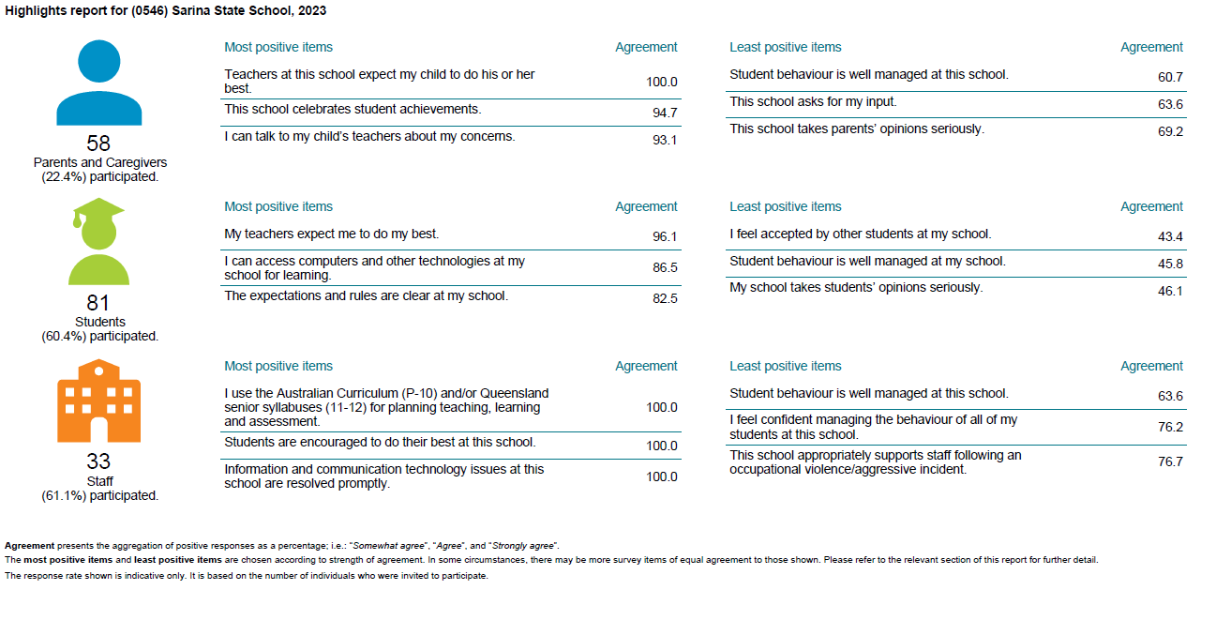
The 2023 School Opinion Survey was released last week. The results are a credit to the work that has been accomplished over the last 12 months by all staff. The full School Opinion Survey is available on our school website. Some positive outcomes for our school, and some work to be done.
Outside School Hours Care
A proposal to host an Outside School Hours Care presented to P&C. This is a two-step tender process. We are now is step 2 and have had some providers visit the school. I will keep parents posted when the Outside School Hours Care will commence operation.

Important message regarding school starting time this term.
Teacher Aid Agreement
The Teacher Aides’ enterprise bargaining agreement has seen the following changes:
Teacher aides will see greater job security through the simplification and standardisation of working hours. This means that teacher aides no longer need to complete extra hours for annual days off (ADO), they will have set starting and finishing times.
Therefore, due to teacher aides starting times changing the before school start time to school will be 8.30 am not 8.15 am. This has been endorsed by the P&C. We do not have enough staff to cover PGD before 8.15am. Students are to arrive no earlier than 8.30 and will go straight to class at 8.45 bell time, there will be no before school play. Students who arrive before 8.30 will be unsupervised and the school can take no responsibility if a child is injured. Students who are on buses and arrive at 8.15 will need to sit in the undercover area, where a DP or the Principal will monitor.

Community Partnerships
Thank you to our local businesses.
Local businesses have donated $50.00 per week into the school’s welfare account, this money is being used to purchase fruit from our local IGA each week. I would like to thank Property Targets Australia particularly for organising this and approaching businesses for this to occur.
Local businesses who have committed to this include Alcorns Bakery, Goodes Butchery D & G Horspool, Sarina Hotel, IGA, Barber James. The fruit baskets are making a difference to our students who may not always have a full lunch box. Thank you to our local community businesses.
Healthy Lunch Reminder
Eating a healthy lunch provides more energy, helps with boosting positive feelings and can make a huge difference in the way you think. Students need to come with a good lunch packed each day. Lollies, energy drinks such as prime, mother etc, chips and sweet biscuits should not be in lunches. These give a short burst of energy that is not sustained and are not filling. Sandwiches, fruit and vegetable snacks, cheese snacks, fruit drinks and milk are all foods that contain higher concentrations of vitamins, minerals and antioxidants and they promote energy. Please take the time to prepare a healthy lunch for your child or a healthy tuckshop lunch.

Useful parent tips.
Parents are significant partners in student learning. 5 questions you can ask your child/children.
- What did you learn today?
- How did you do?
- What did you do if you didn’t understand?
- How can you improve on your learning?
- What are you most proud of?
Our 4 School Expectations

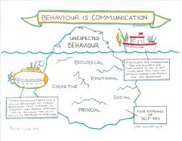

What is central to do when considering consequences is to apply them, and then let the child restore, re-enter, restart. At Sarina students are provided with a social and emotional program on re-entry targeting their particular behaviour. This allows them to resume learning, with the skills to manage their behaviour.

Celebrating Positive Behaviours
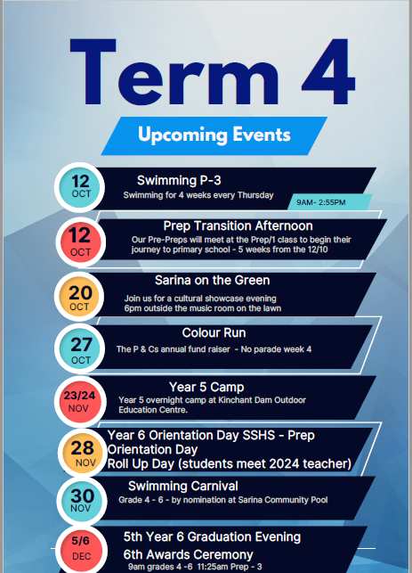
At Sarina State School positive behaviours are celebrated through recognition at our weekly parade, where students who received 20 Kiki Coins are presented with a certificate and pencil on parade. Teachers have their own class rewards system to celebrate and reinforce positive behaviours.

OUT AND ABOUTS

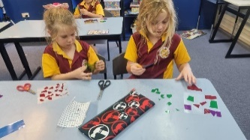
This term 1A are learning about Light and Sound. They have learnt about objects that are sources of light- (natural and artificial) and objects that are reflectors of light. As a fun side activity, students made a stained-glass window from cellophane and sticky contact. We discussed colour combinations and transparency as well. Students were highly engaged and loved it!
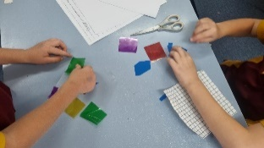

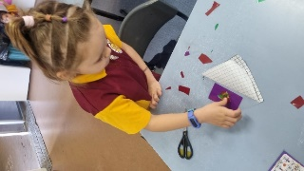
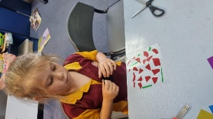
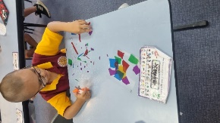
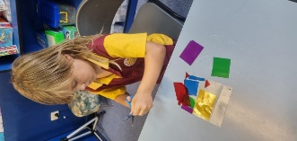

COW SPOTTING!
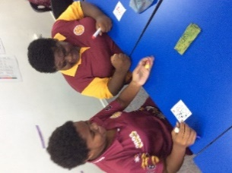
6B playing a math chance game called ‘cow spotting’ and enjoying a Kahoot about language features used in advertisements.
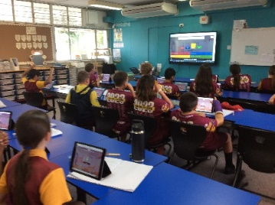
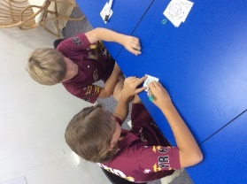
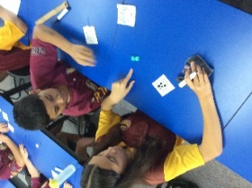
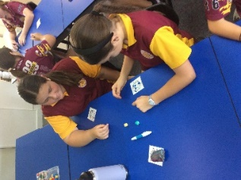

SWIMMING
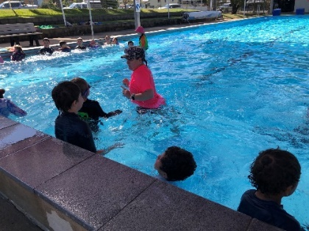
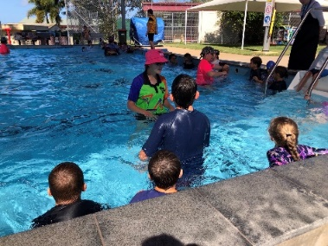
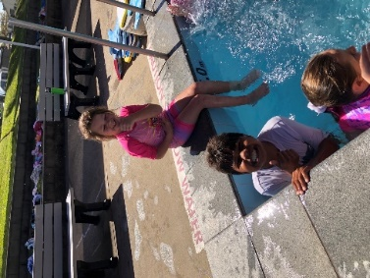
Has started for prep to year 3.

ATTENDANCE EVERY DAY COUNTS
School absenteeism can impact significantly on a student’s learning and wellbeing. Every Day Counts is a State-wide initiative that aims to assist in improving student attendance at school through a shared commitment by students, parents, caregivers, schools and the community.
To do this, Every Day Counts promotes four key messages:
- all children should be enrolled at school and attend on every school day
- schools should monitor, communicate and implement strategies to improve regular school attendance
- truanting can place a student in unsafe situations and impact on their future employability and life choices
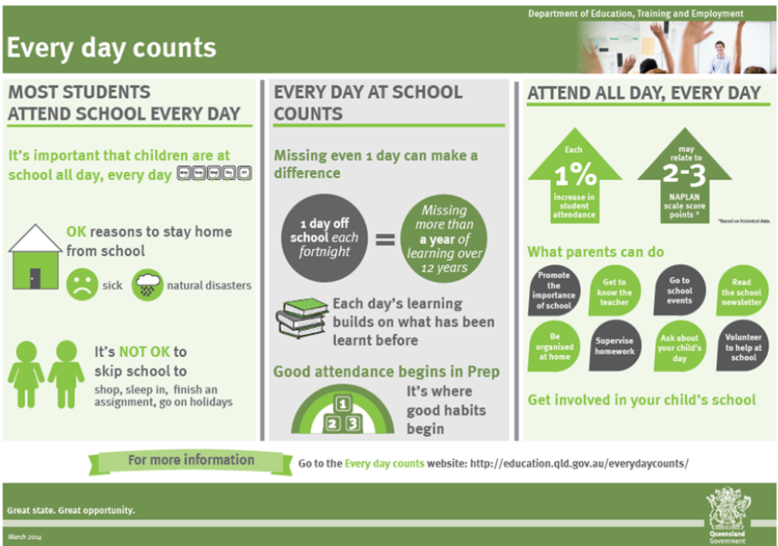
- attendance at school is the responsibility of everyone in the community

Warm regards till next insight.
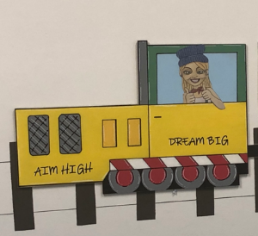
Miss Emelie Adams
Principal

All aboard the Sarina State School train

