13th March 2023
Home Reading 2023
Home reading has begun and students have been bringing home readers (decodable and reader) throughout the term. This year we are using decodable readers to support our students in the early years develop their reading following the code taught in class. Those students who have developed the code fluently will come home with a reader also.
Decodable readers
These decodable books, set out to match the sounds the students have been explicitly taught-the initial code and extended code. Decodable books allow students to build confidence and fluency, revising the sounds they have already learnt in class. Students keep the decodable book for the four nights to practice building their confidence and fluency and bring the book back and their reading log on Friday. This allows their teacher to change the reader. Please record on the reading log the four nights of reading for each of the decodable readers.

Levelled readers
Our students will not be assigned a levelled number for reading. Once students have learnt the code, they should be able to read books. Of course, there may be words they may not know. As they are reading with you follow the prompts below to support your child in reading that word. These books may have a number on the book (please disregard this number), some of these books may be easier than others. Reminder that home reading is to build confidence and fluency.
Students will be encouraged to read a variety of different books, especially information books, as this will help build their background knowledge and build their vocabulary.
Please write the name of the book your child brings home to read and record the number of nights they have read. Return the book with the reading log and new book will be chosen.

Comprehending- understanding what has been read
At the end of reading the book, ask questions from the book e.g. Who, What, Why, When, How- this will help with building understanding of what was read. If the book is an information book, discuss what was learnt e.g. What did you find out about spiders?

How do I help my child read?
- Use a tracking finger to hold the position of reading and have your child slide it along as they read.
- Always stop and look at the whole word from left to right.
- If an error is made, ask your child to try blending (sounding out) again. Then re-read the complete sentence – this helps with fluency and understanding.
- If your child forgets the sound- give them the sound- sound the word together- re-read the word and sentence again.
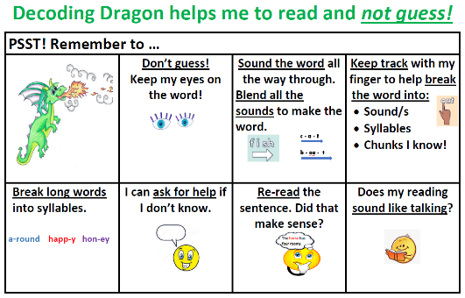
To support our students when they come to a word they don’t know, we use the Decoding Dragon strategies- to avoid guessing.

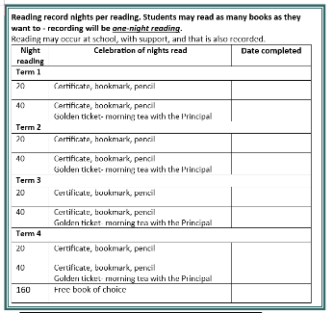
Home reading celebrations.
As we value reading at Sarina State School, we want to celebrate with all our students. In the student’s home reading log, record the night’s reading. Students may read as many books each night, the recording in the reading log will be per night reading.
If you have any questions or concerns, please see your child’s teacher.

Yours in reading

Mrs Wardrop Ms Adams
HOD-C Principal

