Sarina State School Term 1 Week 5 Insight
Dream Big. Aim High.

This year commenced with enthusiastic and excited students ready to be back into their 2023 classrooms prepared for learning. As we approach the middle of term 1, thank you to all our staff and parents who have made the beginning of 2023 a smooth and calm start to the year.
The prep classes began the year with a play-based focus for their first fortnight, settling into school life and a new environment. Our teaching staff work hard to ensure they build relationships with students and families to make school life a great place to be every day.
Our parades on a Friday have had an impressive turnout, with our new student leaders organising and preparing the parade. A slight change to our behaviour reward to reinforce the focus of the week, has been rolled out smoothly, with students receiving a Kiki certificate and a pencil for student of the week.
QSchools has also been adopted as our media sight for information, school notifications, news feeds and all school details. This sight also has our up and coming calendar events. To download simply go to your APP store and type in QSchools then look for our school. If you have troubles downloading please ask at the front office.
This year is our quadrennial review year. What does this mean? All school policies, systems and processes over the last 4 years, will be reviewed by committees and staff. As these documents are rewritten in draft form, information will be sent to parents through the P&C, and on our QSchools site. If you would like to know more and/or join a committee please let the office know.
Policies to be reviewed: Student Code of Conduct, including our Behaviour for Learning process, Reading policy, and our Student and Staff Wellbeing policy.
The 4-year strategic plan will be written after the review process has been completed. This plan outlines the Vision of our school over the next 4 years. Parents will be kept up to date through QSchools news feeds.
Annual Improvement Plan 2023 has been endorsed by the P&C and the Assistant Regional Director Mr Brendan Smith. This document is available on our website and a shorter version is in the front foyer for parents to peruse.
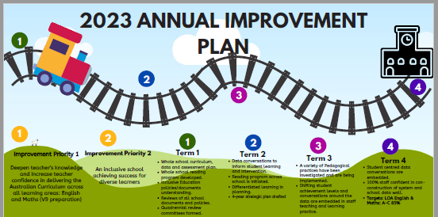

School Calendar Updates
NAPLAN 15,16,17 March
P&C 6th March
P&C AGM 20 March TBA
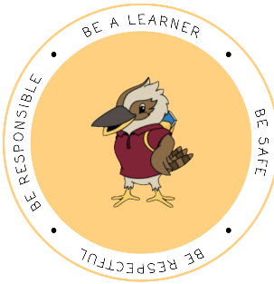

Kiki Coin

The Golden Ticket
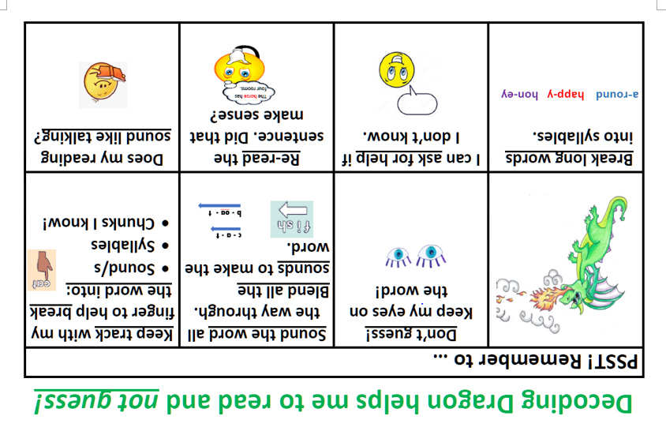
Reading is an important part of learning. In our homework students should be reading every night. In the early year’s students have a reading log where they record nights read. Each student from prep to year 2, to celebrate nights reading, receives acknowledgement for their reading. To help with their reading don’t forget the Decoding Dragon strategies.
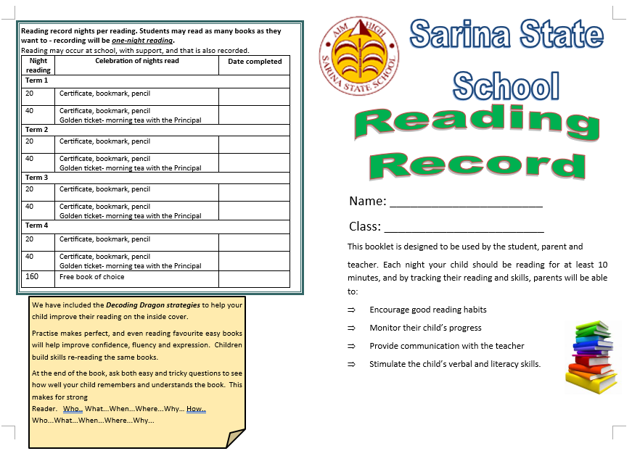
Useful parent tip.
Parents are significant partners in student learning. 5 questions you can ask your child/children.
- What did you learn today?
- How did you do?
- What did you do if you didn’t understand?
- How can you improve on your learning?
- What are you most proud of?

Healthy Lunches

Eating a healthy lunch provides more energy, helps with boosting positive feelings and can make a huge difference in the way you think. Students need to come with a good lunch packed each day. The tuckshop also has a variety of healthy food for students. Lollies, chips and sweet biscuits should not be in lunches. These give a short burst of energy that is not sustained and are not filling. Sandwiches, fruit and vegetable snacks, cheese snacks, fruit drinks and milk are all foods that contain higher concentrations of vitamins, minerals and antioxidants and they promote energy. Please take the time to prepare a healthy lunch for your child or a healthy tuckshop lunch.
ATTENDANCE
School absenteeism can impact significantly on a student’s learning and wellbeing. Every Day Counts is a State-wide initiative that aims to assist in improving student attendance at school through a shared commitment by students, parents, caregivers, schools and the community.
To do this, Every Day Counts promotes four key messages:
- all children should be enrolled at school and attend on every school day
- schools should monitor, communicate and implement strategies to improve regular school attendance
- truanting can place a student in unsafe situations and impact on their future employability and life choices
- attendance at school is the responsibility of everyone in the community
TUCKSHOP SURVEY
We would like to know what you think about Sarina State School’s tuckshop.
https://www.surveymonkey.com/r/37597FB
The P&C are needing feedback regarding the tuckshop due to rising costs and lack of volunteers.

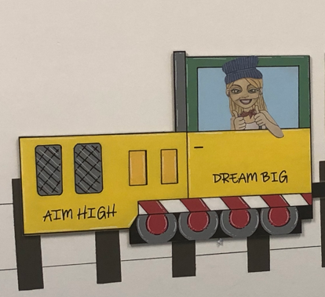
Warm regards till next insight.
Miss Emelie Adams

