

**Sarina State School Term 3 Week 1 Insights**

*Our vision: Quality Education Equal Opportunity*

*Our motto: Dream Big. Aim High.*

**Welcome to Term 3**

Welcome to term 3. Last term flew by and it is hard to believe we are half way through the school year. The start of a new term is always exciting. It has been lovely to see the children and families this week. Welcome back everyone.

A recap of term 2, saw a busy term with a lot of things happening. Our sports carnival was a highlight of the term. It is always great to see the students and staff dressed in their colours supporting their team. War cries were loud and proud. Congratulations to Hinkler, the winning team.

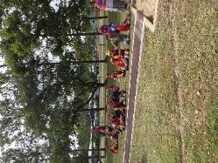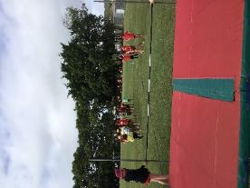

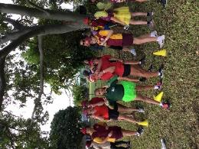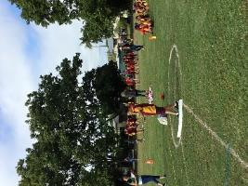

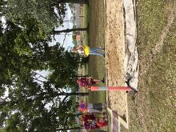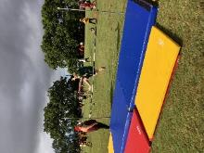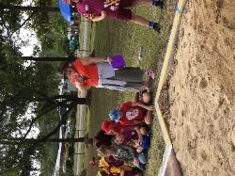

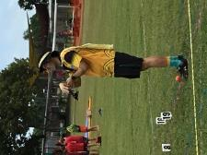

Another highlight of our term was the *NAIDOC Parade.* Thank you to Miss Sian and Miss Dittmar for organising our Dance Group and arranging practice times with these students. We also welcome Miss Sian as our Community Education Counsellor (CEC).

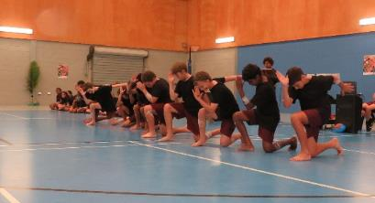

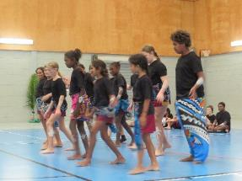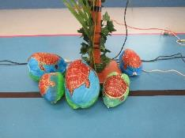

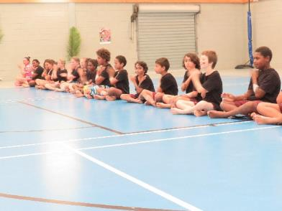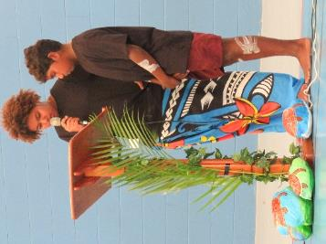

A group of year 6 students in week 7 headed off to Konomie Island Environmental Education Centre for a week. The students learned how to look after our environment and sea life. The students learnt about renewable energy and resilience and lifecycles, which is part of the Australian Curriculum. Students experienced a variety of activities each day including snorkelling over the coral reefs, investigating sustainable living practices, kayaking, outrigging, marine studies and a number of other activities.

This camp will be offered again next year to year 6 students.

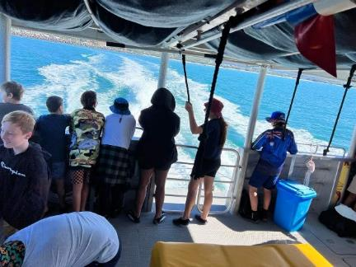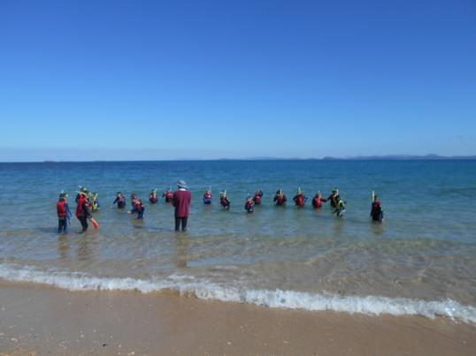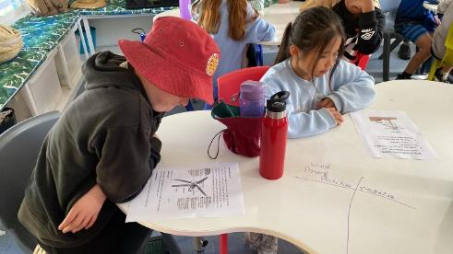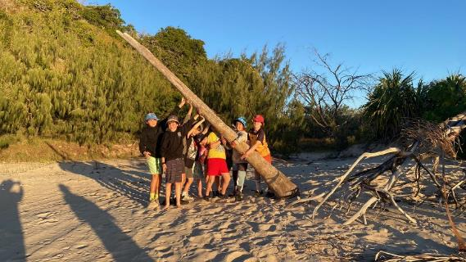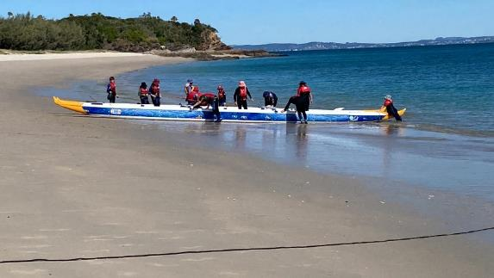

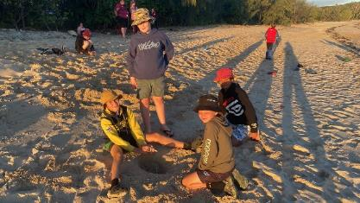

**Chaplaincy Week**

What a great week for our beautiful Chappy Marg. The crazy sock day raised money towards chaplaincy. We thank the great work Chappy does with our students at Sarina State School. Chappy’s role encompasses many things, from breakfast club to working with our students in the curriculum area, to working with Kiki our favourite kookaburra mascot. Chappy also runs a variety of programs for our students including a garden-based learning club and individual programs to help students regulate and build resilience.

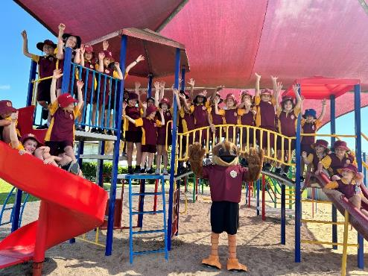

**Coding Club**

Kelly Ozegovic has started Coding club in the computer lab, this is for years 4 and upwards. 2nd break play times Thursday and Fridays. The students will be doing Lego EV3 bots, and some at the computers working on Hour of Code.com or Scratch.mit, doing coding activities. Thanks Mrs O.

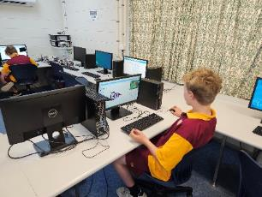

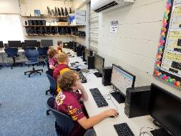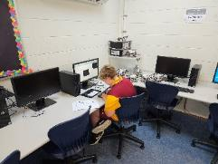

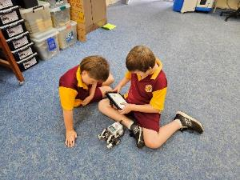

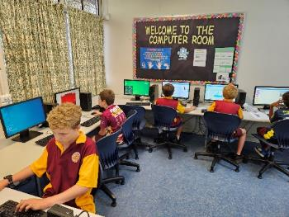

**P&C News.**

On Wednesday 21st June the P&C held our first disco for the year. The theme was fluro and it certainly lived up to its name! **The P&C meets every 2nd Wednesday of the month at 3.30 pm**. And it would be great for parents to get involved. The P&C have some fund-raising ideas for our school, including new oval bench seating. The P&C donated money for our year 5 and 6 lunch time seating $15,000 and have other ideas to improve our school grounds. They are very proactive and passionate about providing for our school’s needs to assist in improving student outcomes. Come along and join in, the more parents we have at our meetings the more ideas we generate. It is also a great way to meet other parents.

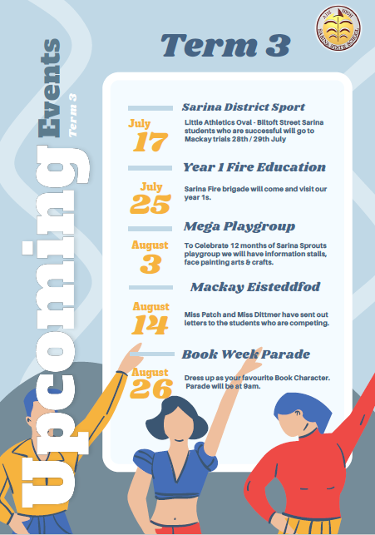

**Curriculum News Out and About in our Classrooms.**

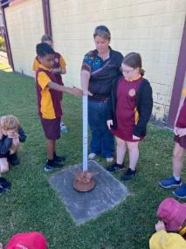**5A** conducted an experiment on how the different size of impactors affects the size of craters made after impacting the surface. We determined that the larger the impactor, the larger the crater and rays.

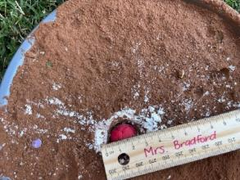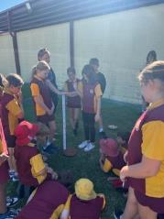

***6B*** *applying their science knowledge and skills of circuits to put lights into a cardboard house.’*

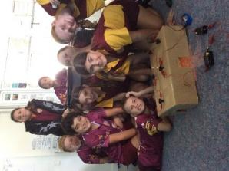

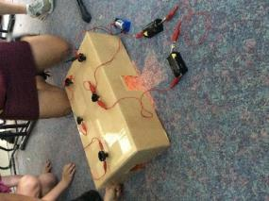

***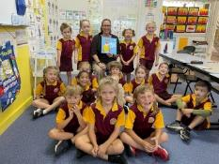****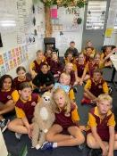****National Simulation Storytime 2023- Speedy Sloth***

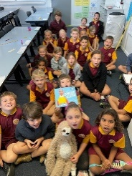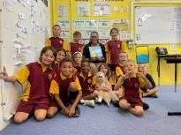

Thank you, Mrs Wardrop, for visiting every class in the school and reading the Speedy Sloth to our students. Reading is a wonderful gift that inspires joy.

Reading to your child/ren or listening to them read is a great way to encourage reading.

***Little Bits***

*Last year Mrs Oaks and I applied for a grant from the North Queensland Port Authority and received funding to purchase sphero little bits. We have purchased 10 of these kits moving forward into STEAM, in 2024. Year 6 leaders had the fun of being the first students to “play” with the kits. They had their photos taken as part of a photo shoot for the Authority.*

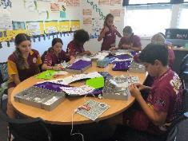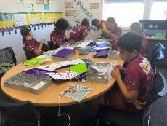

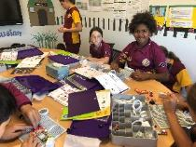

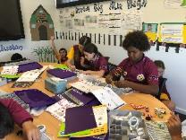

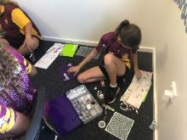

**Under 8’s Day Week 5**

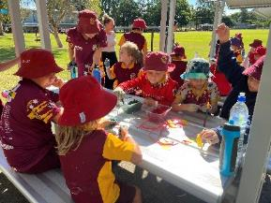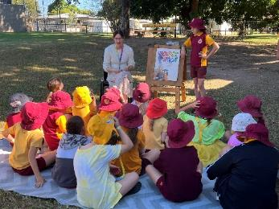Under 8s day was well represented by our Kindies and playgroup parents with their littlies. Thanks, Kate, for the organisation of this morning.

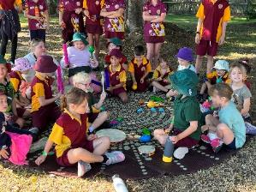

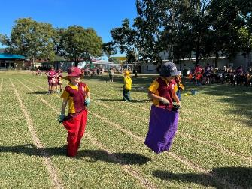

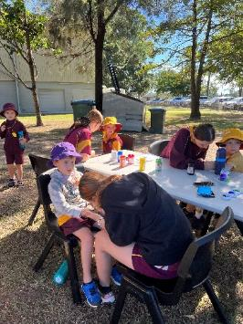

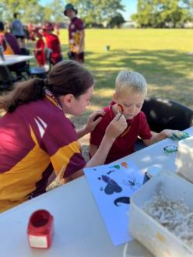***Big shout out to Sarina High students for their creative face painting.***

***School Review***

In week 9 our school had its 4-year school review. Thank you to our parents and community who were approached as part of this review for participating. A positive comment from the Review was the feedback the reviewers got from our students. Our students “out of the mouths of babes” as Louise (panel reviewer) put it, think our teachers are all awesome. The students know our teachers care about them and help them learn. They went so far as to tell the reviewers that the learning wall in one particular classroom “helped me get a B!” AWESOME!

Over term 3 and into term 4 we will begin to write our 4-year strategic plan. Everyone, including community and parents will have input into this, it is about our vision or dream for our school and our students.

As part of the 4-year strategic plan, reviews of school documents and policies have been happening since semester 2 2022, and from these new documents have been written or updated. You can find these updated documents on our website: <https://sarinass.eq.edu.au/>

Student Code of Conduct and Wellbeing, Parent Code of Conduct, Parent and Community Engagement Program and our Student Learning and Wellbeing Framework.

As part of our document review of the Student Code of Conduct, our school decided to implement Positive Education philosophy into our school. This replaces the PBL program that the school had in place.

***Positive Education aligned to Behaviour Management***

I would like to clarify the intention of positive education roll out in our school and the withdrawal of being a PBL school. PBL is a set behaviour program, positive education is a combination of traditional education principles with the study of happiness and wellbeing. Martin Seligman’s model PERMA and the Values in Action (character strengths). On pupil free days the whole staff completed the VIA character strengths survey as part of this initiative.

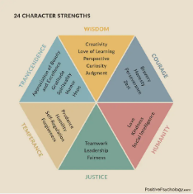The PERMA and PERMAH frameworks encompass five main elements that Seligman premised as critical for long-term wellbeing.

Positive emotions

Engagement

Relationships

Meaning

Accomplishment

+ Health

The positive education team is working on how this will look in our school. Some things that they identified and fed back to staff is the Kiki reward system. This is when we changed the reward system to the Kiki coins.

As part of our 4-year strategic plan the design and co-construction of positive education will be a whole school process. Presently the positive education team is working on how this will look, while looking at behaviour data, weekly focus lessons for the term, non-negotiables, routines and this term the new Buzz of the Week (class of the week) award.

This does not mean our 4 expectations will change, the reviewed behaviour matrix will not change, buddy class does not change, classroom expectations aligned to the school expectations have not changed. The three tiers of behaviour will not change.

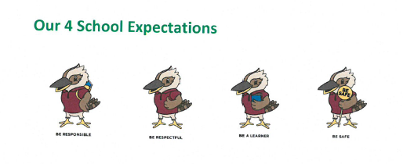What does change is the way we approach behaviour in our classrooms and the playground in a positive proactive way.

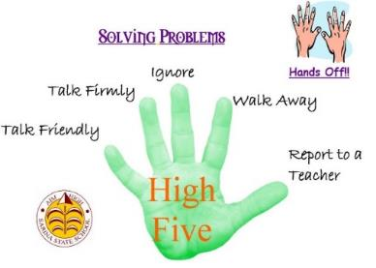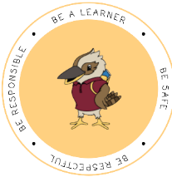

Kiki Coin

As we approach the middle of the year many students are now reaching the target of 60 Kiki coins. Well done, these students will receive their Golden Kookaburra on Friday parades. Contact home will be made to parents and carers so you can attend the parade and celebrate with your child/ren.

The Golden Ticket

Reading is an important part of learning. In our homework students should be reading every night. In the early year’s students have a reading log where they record nights read. Each student from prep to year 2, to celebrate nights reading, receives acknowledgement for their reading. At the end of the term students who have read a certain number of books are issued with a Golden Ticket. This Golden Ticket is their ticket for morning tea with the principal. To help with their reading don’t forget the Decoding Dragon strategies.

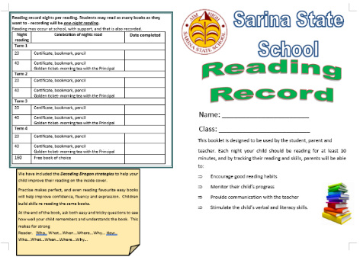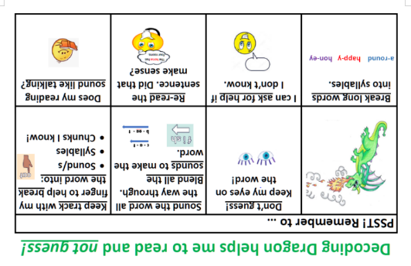

**Useful parent tips.**

Parents are significant partners in student learning. 5 questions you can ask your child/children.

1. What did you learn today?
2. How did you do?
3. What did you do if you didn’t understand?
4. How can you improve on your learning?
5. What are you most proud of?

**Healthy Lunches**

Eating a healthy lunch provides more energy, helps with boosting positive feelings and can make a huge difference in the way you think. Students need to come with a good lunch packed each day. The tuckshop also has a variety of healthy food for students. **Lollies, chips and sweet biscuits should not be in lunches.**  These give a short burst of energy that is not sustained and are not filling. Sandwiches, fruit and vegetable snacks, cheese snacks, fruit drinks and milk are all foods that contain higher concentrations of vitamins, minerals and antioxidants and they promote energy. Please take the time to prepare a healthy lunch for your child or a healthy tuckshop lunch.

**ATTENDANCE**

School absenteeism can impact significantly on a student’s learning and wellbeing. Every Day Counts is a State-wide initiative that aims to assist in improving student attendance at school through a shared commitment by students, parents, caregivers, schools and the community.

To do this, Every Day Counts promotes four key messages:

* all children should be enrolled at school and attend on every school day
* schools should monitor, communicate and implement strategies to improve regular school attendance
* truanting can place a student in unsafe situations and impact on their future employability and life choices
* 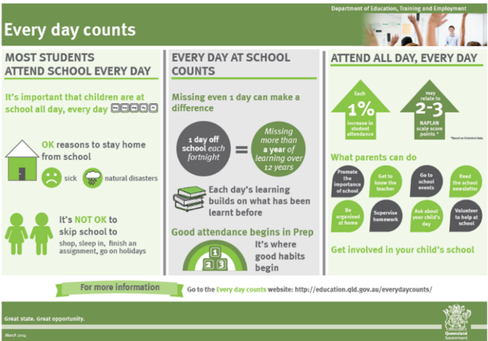attendance at school is the responsibility of everyone in the community

**Staffing**

Last term we farewelled a number of teachers at our school. Mrs Pickering has gone to Maryborough as an SEP teacher, Mr and Mrs Bidgood have taken leave for the semester to travel, Mrs Murray has returned to Bowen SHS, Miss Sweeney has taken leave and Ms Dallow has taken maternity leave for the semester. We wish them well in their endeavours.

Replacing Miss Sweeney in 4B is Mrs Taylah Pershouse and Mr Bidgood has been replaced with Mr Brent Francis. At this stage we have not replaced Mrs Pickering or Mrs Bidgood. We are currently looking for a replacement teacher for 5B, Ms Dallow’s class, Ms Paton is relieving for the time being.

**Warm regards till next insight.**

**Miss Emelie Adams All aboard the Sarina State School train**

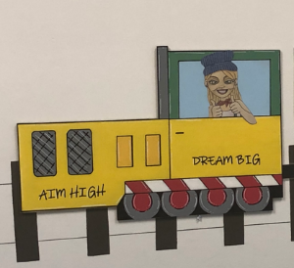**Principal**