Smiling Minds
Smiling Minds has been launched at Sarina State School. This program has been selected to support our student’s mental health and wellbeing and promote mindfulness which is proven to help our kids feel calmer.

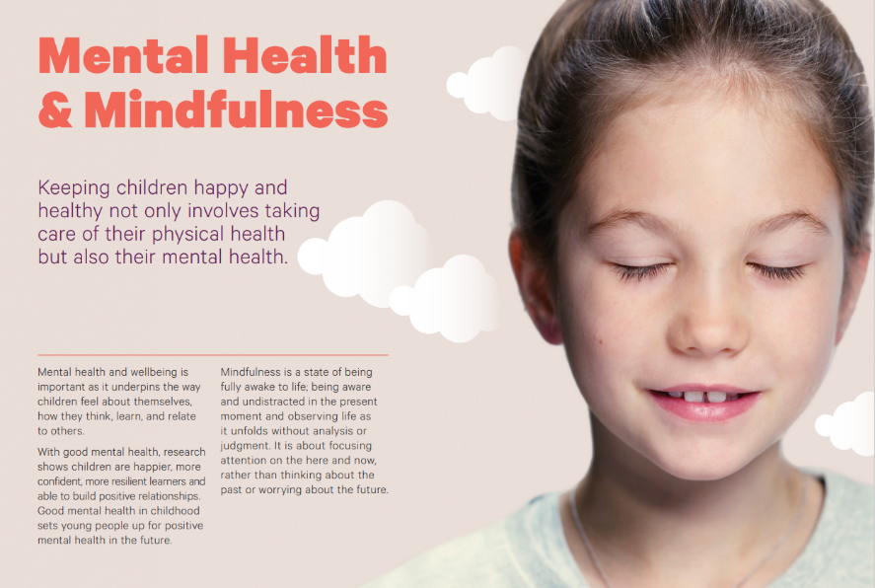
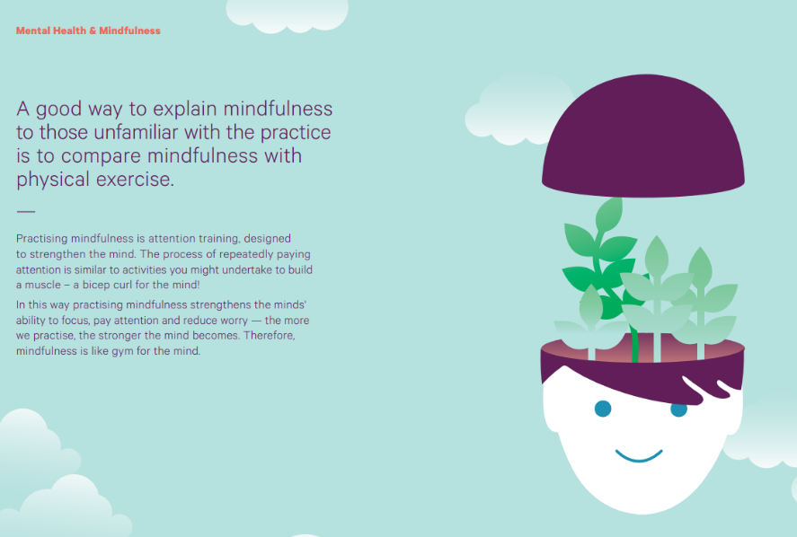

Mindfulness strategies can support your family at home too. There is a free app you can download in the Apple Store or Google Play Store.
